**Course One**

# Foundations of Data Science



# Instructions

Use this PACE strategy document to record decisions and reflections as you work through this end-of-course project. You can use this document as a guide to consider your responses and reflections at different stages of the data analytical process. Additionally, the PACE strategy documents can be used as a resource when working on future projects.

# Course Project Recap

Regardless of which track you have chosen to complete, your goals for this project are:

* Complete the PACE Strategy Document to plan your project while considering your audience members, teammates, key milestones, and overall project goal.
* Create a project proposal for the data team.

# Relevant Interview Questions

Completing this end-of-course project will empower you to respond to the following interview topics:

* As a new member of a data analytics team, what steps could you take to get 'up to speed' with a current project? What steps would you take? Who would you like to meet with?
* How would you plan an analytics project?
* What steps would you take to translate a business question to an analytical solution?
* Why is actively managing data an important part of a data analytics team's responsibilities?
* What are some considerations you might need to be mindful of when reporting results?

**Reference Guide**

This project has three tasks; the following visual identifies how the stages of PACE are incorporated across those tasks.

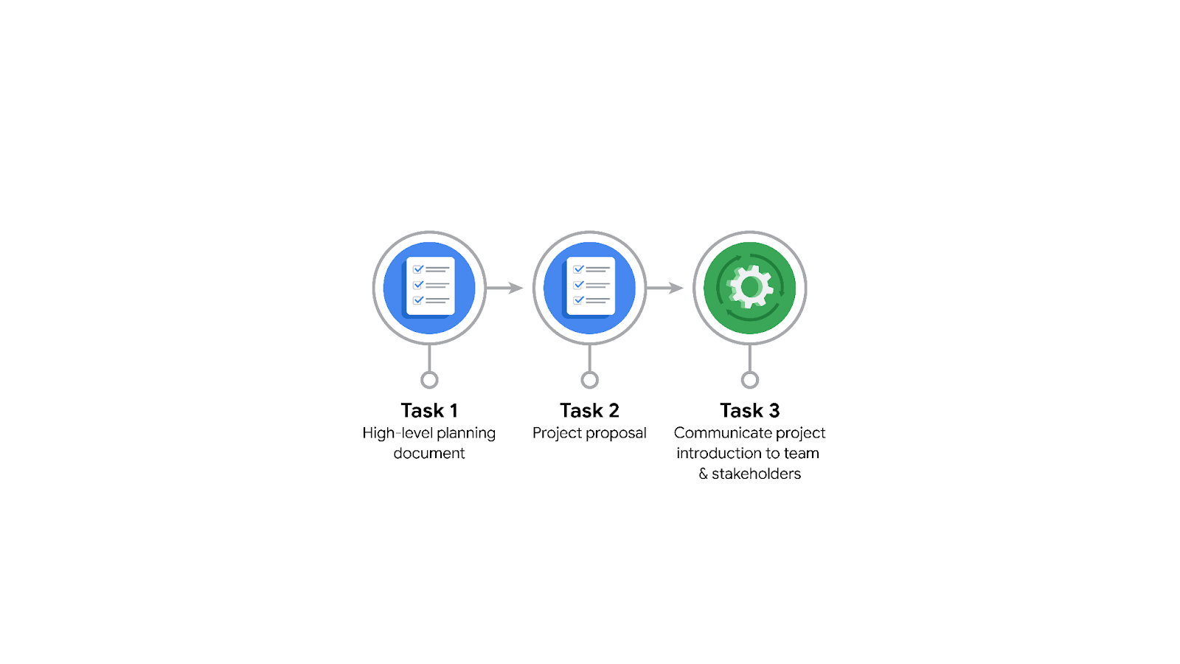

**Data Project Questions & Considerations**

**PACE: Plan Stage**

* Who is your audience for this project?

The Data Team of Waze .

* What are you trying to solve or accomplish? And, what do you anticipate the impact of this work will be on the larger needs of the client?

We want to build a machine learning model that predicts churn. Churn is basically the act of uninstalling the Waze app or simply neglecting to use it. By doing this, we will be able to get high retention rates of users to improve customer retention and productivity.

* What questions need to be asked or answered?

Who uses the app?

Why do people stop using the apps?

When do you people use the apps?

What is the main use of app?

* What resources are required to complete this project?

The data of people who use the app. (A database)  
Data tools and software

* What are the deliverables that will need to be created over the course of this project?

Project Plan

Data Collection Plan

Dataset

Data Cleaning and Preprocessing Scripts

Exploratory Data Analysis

Statistical Analysis

Data Visualization

Insights and Recommendations

Modeling and Predictive Analysis

Testing and Evaluation of Model

Dashboard for Interactive Visualization

Data Privacy and Security

Executive Summary

Presentation to Stakeholders

Final Report

## 

## **THE PACE WORKFLOW**

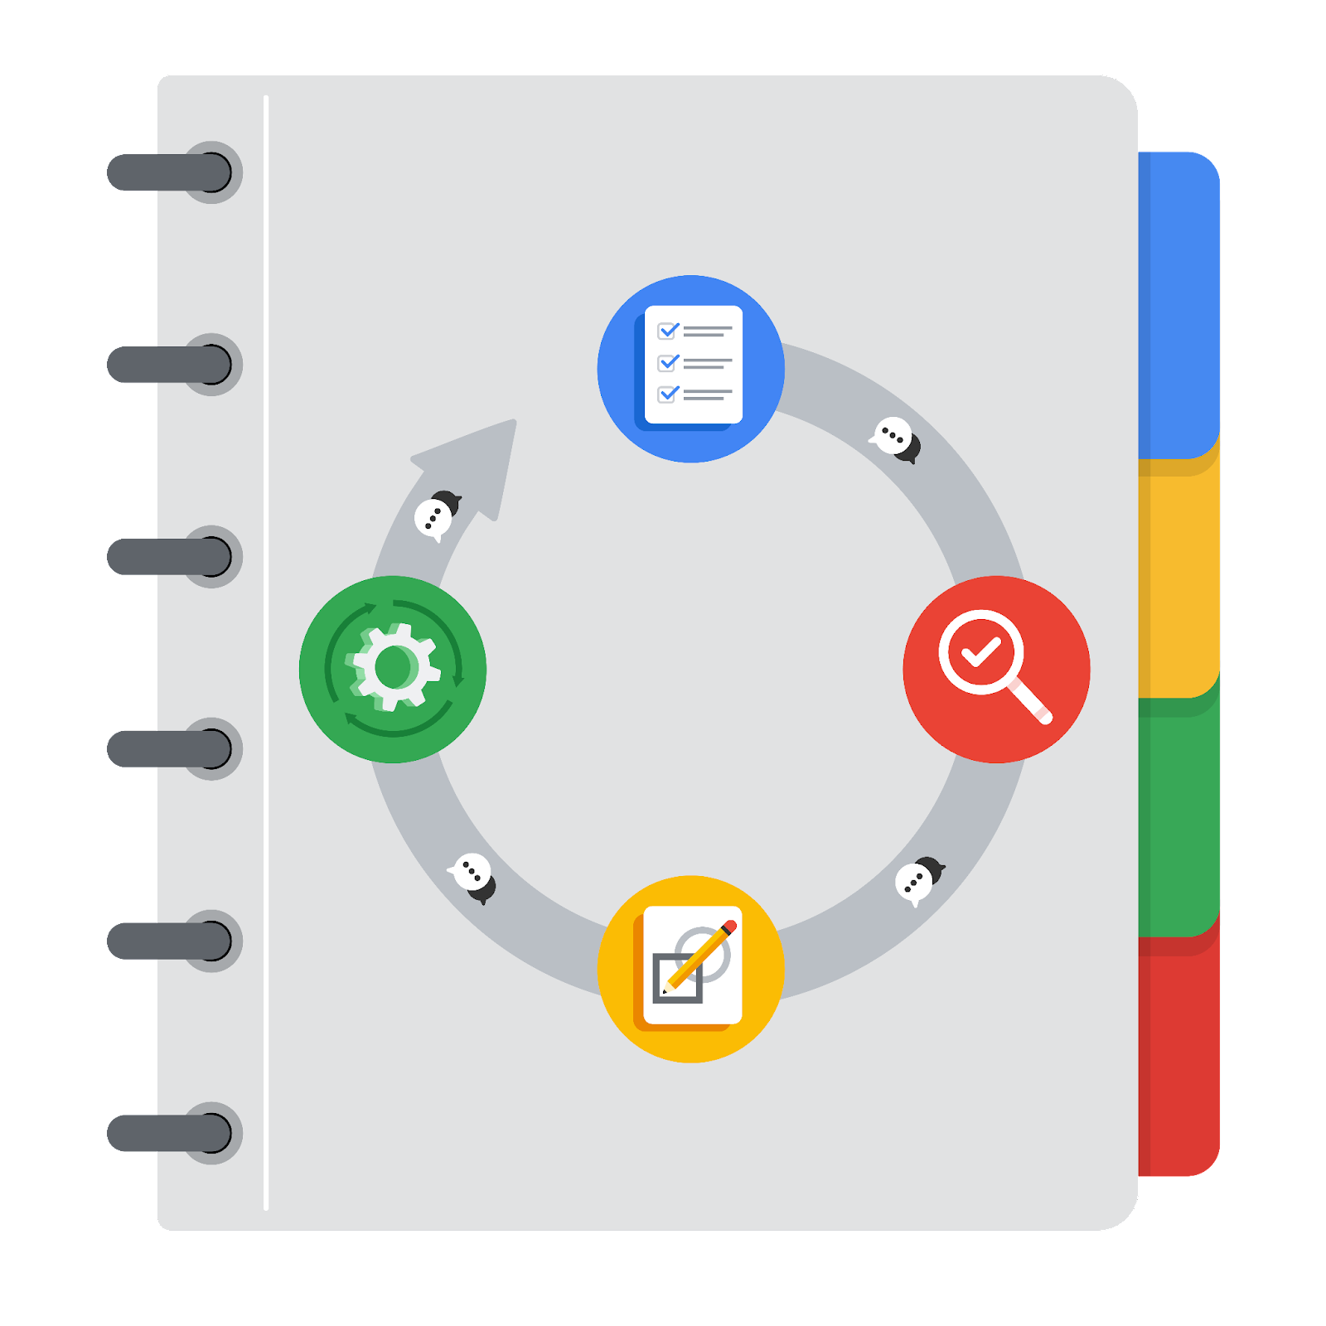

**[Alt-text: The PACE Workflow with the four stages in a circle: plan, analyze, construct, and execute.]**

You have been asked to demonstrate for the company's data team how you would use the PACE workflow to organize and classify tasks for the upcoming project. Select a PACE stage from the dropdown buttons. A few tasks involve more than one stage of the PACE workflow. Additionally, not every workplace scenario will require every task. Refer back to the Course 1 end-of-course portfolio project overview reading if you need more information about the tasks within the project.

### 

### **Project tasks**

Following are a group of tasks your company’s data team has determined need to be completed within this project. The data analysis manager has asked you to organize these tasks in preparation for the project proposal document. First, identify which stage of the PACE workflow each task would best fit under using the drop down menu. Next, give an explanation of why you selected the stage for each task. Review the following readings to help guide your selections and explanation: [The PACE stages](https://www.coursera.org/learn/foundations-of-data-science/supplement/4OtHr/the-pace-stages) and [Communicate objectives with a project proposal](https://www.coursera.org/learn/foundations-of-data-science/supplement/79Ysh/communicate-objectives-with-a-project-proposal). You will later reorder these tasks within a project proposal.

1. **Evaluating the model: Construct**

Why did you select this stage for this task?

During the Construct Stage is where the model is selected, built and evaluated and tested to see the accuracy and the recall

1. **Conduct hypothesis testing: Plan** **and** **Analyze**

Why did you select these stages for this task?

In the plan stage, the path is given to get the scope of the analysis and formulate hypotheses you want to investigate.  
The Analyze stage is where data is cleaned and EDA takes place for hypothesis testing

1. **Begin exploring the data: Analyze**

Why did you select this stage for this task?

This is the stage where you clean the dataset and make EDA to uncover relationships between data.

1. **Data exploration and cleaning: Analyze** **and Analyze**

Why did you select these stages for this task?

This is the stage where you clean the dataset and make EDA to uncover relationships between data

1. **Establish structure for project workflow (PACE): Plan**

Why did you select this stage for this task?

This is the stage where the scope of the problem is determined.  
The information needs of the organization is also determined here

Questions are asked using the 5 why’s.

1. **Communicate final insights with stakeholders: Execute**

Why did you select this stage for this task?

This is the stage where presentations of outcomes and solutions are presented to stakeholders

1. **Compute descriptive statistics: Analyze**

Why did you select this stage for this task?

This comes in the EDA process

1. **Visualization building: Analyze and Execute**

Why did you select these stages for this task?

Visualizations are made here

1. **Write a project proposal: Plan**

Why did you select this stage for this task?

1. **Build a regression model: Analyze and Construct**

Why did you select this stage for this task?

**Analyze gives the foundation for determining he model to build and construct is where the algorithm is chosen and model is buillt**

1. **Compile summary information about the data: Plan**

Why did you select this stage for this task?

This is where data and information needs are compiled

1. **Build machine learning model: Construct**

Why did you select this stage for this task?

**As i said recently, this stage is where the ml algorithm is chosen and built**